**Applications of Kmap method**

**Objective:**

* To investigate the rules of kmap
* To gain experience working with practical circuits
* To simplify a complex function using kmap

**Required Components and Equipments:**

* AT-700 Portable Analog/Digital Laboratory
* AND, OR, NOT, XOR IC
* Logic State
* Logic Probe(big)

**Experimental Setup (You must draw the IC configurations):**

**Function 1: F(A,B,C,D)=∑(1,3,9,10,13,15)**

With after doing Kmap on Function 1, I got the following equation: A’B’D+ABD+B’C’D+AB’CD’

After launching Proteus I went to P(parts)->simulator preemptive. I selected AND, NOR, OR gate. I also selected a logic state and logic probe(big). After collecting my components I placed four logic states to take input A, B, C, D. With NOT gate I also made A’, B’, C’, D’ from A, B, C, D.With AND gate I added A’ and B’ and later A’B’ with D and got A’B’D gate. In the same process, I created ABD, B’C’D and AB’CD’ with AND gates. Then I added A’B’D and ABD with OR gate(A’B’D+ABD). Also B’C’D and AB’CD’ with another OR grate(B’C’D+AB’CD’).Finally I added A’B’D+ABD,B’C’D+AB’CD’ with an OR gate(A’B’D+ABD+B’C’D+AB’CD’)**.** With the final Or gate output, I added a logic prob(big) to see my expected output.

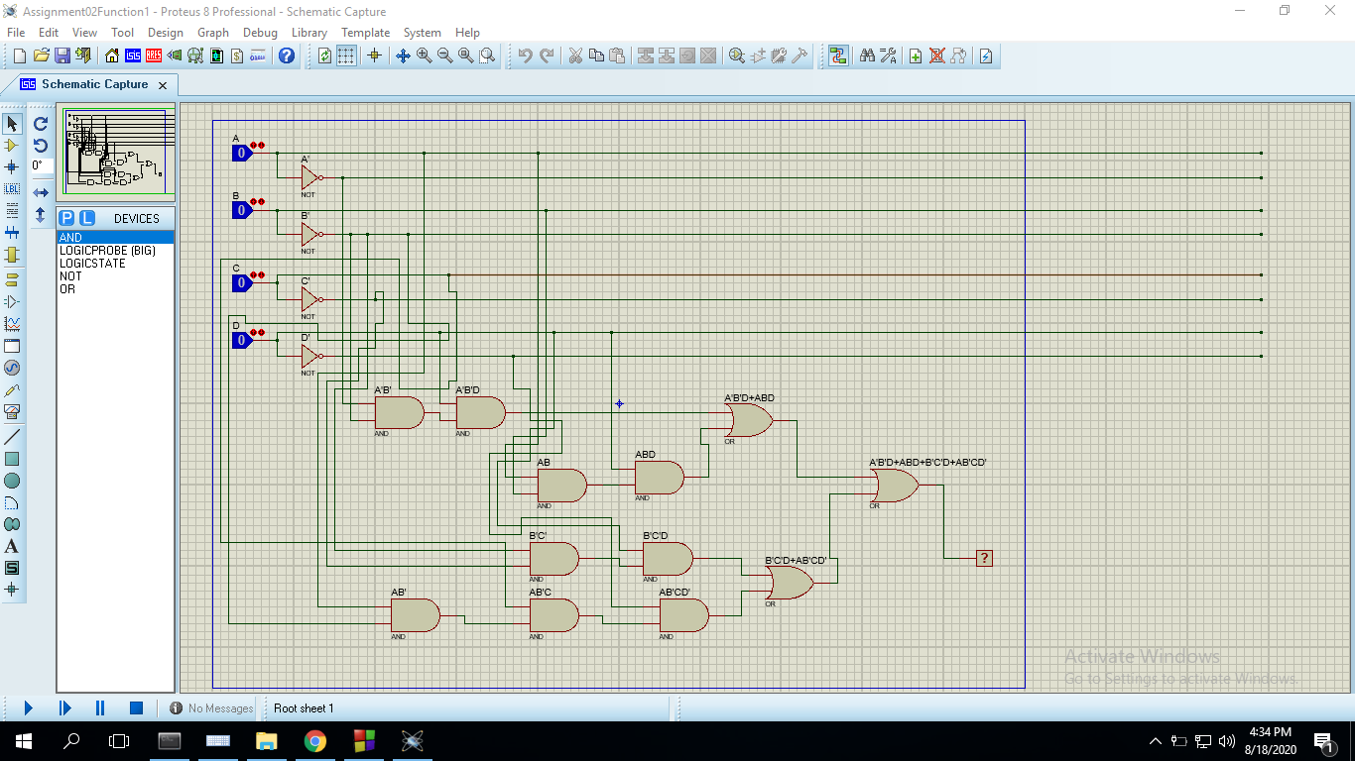

**Function 2: F(A,B,C,D)=∑(1,4,10,15)+d(3,5,13,14)**

With after doing Kmap on Function 2, I got the following equation: A’B’D+A’BC’+ABD+ACD’

After launching Proteus I went to P(parts)->simulator preemptive. I selected AND, NOR, OR gate. I also selected a logic state and logic probe(big). After collecting my components I placed four logic states to take input A, B,C,D. With NOT gate I also made A’, B’,C’, D’ from A, B, C, D.

With AND gate I added A’ and B’ and later A’B’ with D and got A’B’D gate. In the same process, I created ABD, A’BC’ and ACD’with AND gates. Then I added A’B’D and ABD with OR gate(A’B’D+ABD). Also A’BC’ and ACD’ with another OR grate(A’BC’+A’CD’). FInally added (A’B’D+ABD) gate and (A’BC’+A’CD’) with another OR gate. (A’B’D+ABD+A’BC’+ACD’).With the final Or gate output, I added a logic prob(big) to see my expected output.

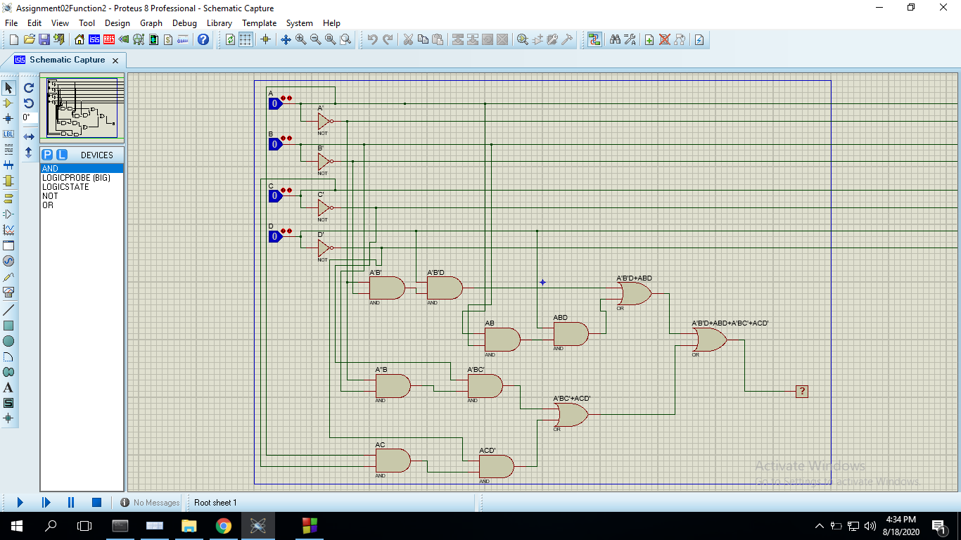

**Results:**

**(Truth Table):**

Function 1: A’B’D+ABD+B’C’D+AB’CD’

|  |  |  |  |  |  |
| --- | --- | --- | --- | --- | --- |
|  | **A** | **B** | **C** | **D** | **F1** |
| **0** | **0** | **0** | **0** | **0** | **0** |
| **1** | **0** | **0** | **0** | **1** | **1** |
| **2** | **0** | **0** | **1** | **0** | **0** |
| **3** | **0** | **0** | **1** | **1** | **1** |
| **4** | **0** | **1** | **0** | **0** | **0** |
| **5** | **0** | **1** | **0** | **1** | **0** |
| **6** | **0** | **1** | **1** | **0** | **0** |
| **7** | **0** | **1** | **1** | **1** | **0** |
| **8** | **1** | **0** | **0** | **0** | **0** |
| **9** | **1** | **0** | **0** | **1** | **1** |
| **10** | **1** | **0** | **1** | **0** | **1** |
| **11** | **1** | **0** | **1** | **1** | **0** |
| **12** | **1** | **1** | **0** | **0** | **0** |
| **13** | **1** | **1** | **0** | **1** | **1** |
| **14** | **1** | **1** | **1** | **0** | **0** |
| **15** | **1** | **1** | **1** | **1** | **1** |

Function 2: A’B’D+A’BC’+ABD+ACD’

|  |  |  |  |  |  |
| --- | --- | --- | --- | --- | --- |
|  | **A** | **B** | **C** | **D** | **F1** |
| **0** | **0** | **0** | **0** | **0** | **0** |
| **1** | **0** | **0** | **0** | **1** | **1** |
| **2** | **0** | **0** | **1** | **0** | **0** |
| **3** | **0** | **0** | **1** | **1** | **X** |
| **4** | **0** | **1** | **0** | **0** | **1** |
| **5** | **0** | **1** | **0** | **1** | **X** |
| **6** | **0** | **1** | **1** | **0** | **0** |
| **7** | **0** | **1** | **1** | **1** | **0** |
| **8** | **1** | **0** | **0** | **0** | **0** |
| **9** | **1** | **0** | **0** | **1** | **0** |
| **10** | **1** | **0** | **1** | **0** | **1** |
| **11** | **1** | **0** | **1** | **1** | **0** |
| **12** | **1** | **1** | **0** | **0** | **0** |
| **13** | **1** | **1** | **0** | **1** | **X** |
| **14** | **1** | **1** | **1** | **0** | **X** |
| **15** | **1** | **1** | **1** | **1** | **1** |

**Discussions:**

**What is the Boolean Equation for the output:**

Function 1: A’B’D+ABD+B’C’D+AB’CD’

Function 2: A’B’D+A’BC’+ABD+ACD’

**Simplify the Boolean equation:**

**Function 1:**

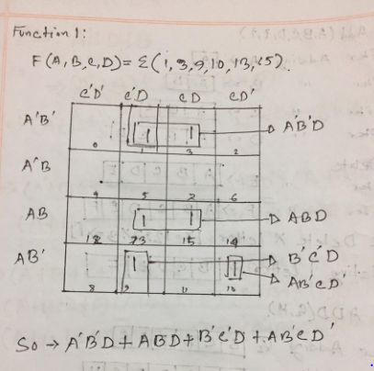

**Function 2:**

